Foodbank COVID-19 Crisis Response
Woking Foodbank on Wheels
The Foodbank has transformed its operations in response to the need for social distancing and a large increase in the need for its services. In March the main centre at the Lighthouse was open three mornings a week and hubs at Sythwood, Sheerwater and Byfleet each opened once a week. These were all closed on 20th March and there is now a van/car delivery service from the Titan warehouse facility in Sheerwater. At the beginning of the year we typically helped 30 – 40 individuals and families per week; in the fourth week of the new operation we made 95 deliveries of food parcels and are operating six days per week.
We continue to work alongside our regular referral partners. We are focussing our support for people unable to afford food, but we are not sticking rigidly to this. We will help anyone who is not able to get to the shops because they are having to self-isolate, although we do try and link such people in with the many newly set up local help groups. We have set up an Emergency Foodbank telephone helpline, that is available between 10am and 12 30pm, Monday to Friday: 07309 115862
On Saturday 21st March a large volunteer team helped us move all our food stocks from the Lighthouse to our warehouse at Titan Storage Solutions in Sheerwater. Our volunteer teams, working in pairs observing social distancing, or as a household group, prepare food parcels. We ask two members of the same household to undertake deliveries using their own car or our van.
Brenda, one our long serving team leaders, is shown with her family below preparing food parcels for delivery
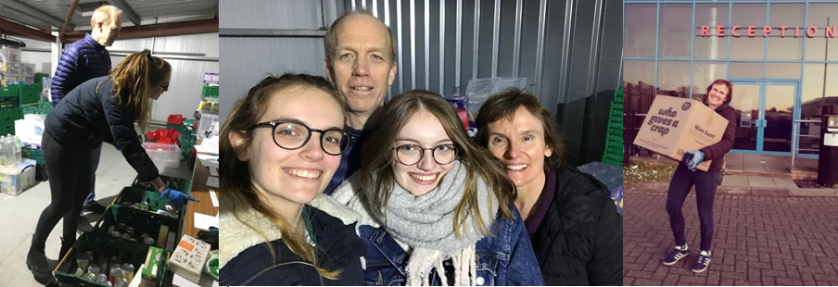
During our first week of deliveries, we made 60 drops. Our second and third week of operation saw a steady rise in referrals and we made 75 drops during week three and 95 in week four. We believe we can increase our deliveries to 120 per week with our existing volunteers. We have had to further expand our hours of working and now have 3 packing and sorting sessions in our warehouse each day, plus two delivery teams out each day between Monday and Saturday. In addition, we have one volunteer dedicated to processing our vouchers and another responsible for organising food distribution and volunteer team rotas. Both are working every day.
Our volunteer network has had to change since we adapted our services. Of our regular 70 volunteers, many have had to dip out for a while but lots are working behind the scenes, answering our telephone helpline, offering advice and helping with administration. We have over 40 volunteers out and about and approximately half of those are new to helping with the foodbank. In week four our volunteers worked over 200 hours and covered 200 miles making deliveries.
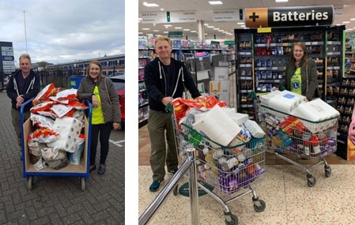
We are grateful to have received excellent donations from our regular and new supporters, including the Christmas Bakery in Worplesdon who supply fresh bread four days a week at a reduced cost. The AWBS International Women’s Club are funding the remaining costs. Also, Woking Lions Charity are running a campaign for us. They are using the funds collected to purchase food, we were amazed by their first delivery.
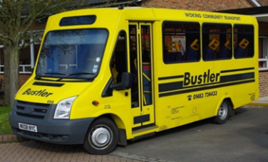
Woking Borough Council have offered their support with transportation by way of the Bustler Community Transport. Bustler drivers have taken on responsibility for the collection of food donated at various supermarkets throughout the town. This has relieved some of the pressure on our permanent warehouse team.
People have continued to be very generous with donations of food and money for which we are extremely grateful. We have also received some generous donations of fresh food and vegetables and are looking for a regular supply of fresh eggs and milk.
A huge thank you to all those who support and volunteer at The Foodbank.

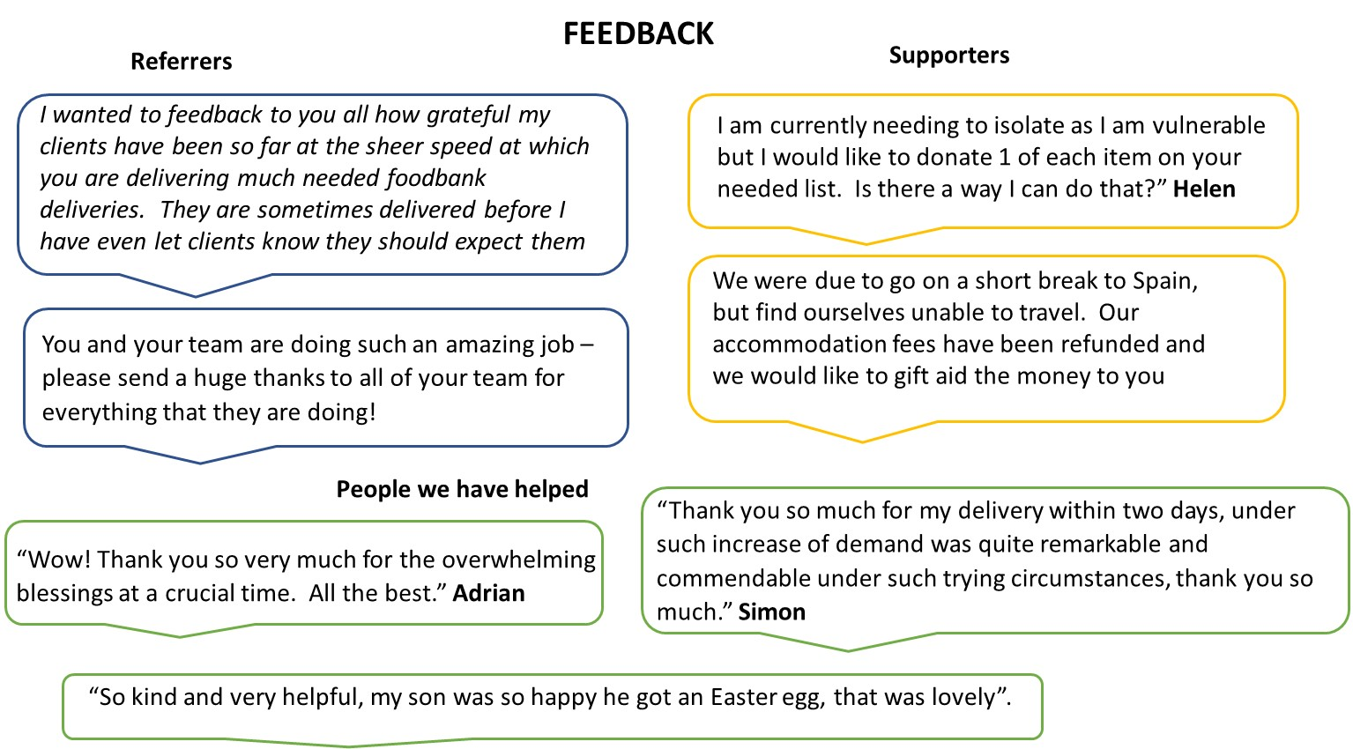
Alison Buckland: info@woking.foodbank.org.uk

